Task 2

Date: 10 JAN 2021

1. Difference between copy by value and copy by reference:

|  |  |  |
| --- | --- | --- |
| **Data types** | | |
| Primitive | Trivial | Composite |
| Number | Undefined | Arrays |
| Boolean | NULL | Functions |
| String |  | Objects |

**Primitive Data Types** are copied **By Value** and **Composite data types** are copied **By Reference**.

Primitive data types are passed, or copied, by value and are immutable, meaning that the existing value cannot be altered the way an array or an object can.

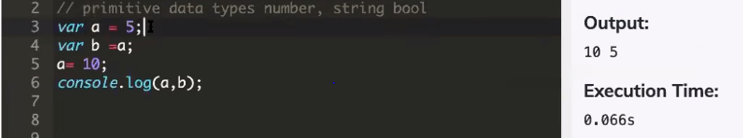

Here we have created two variables, a = 5 and b = a. Since 5 is a number and a primitive value, when we set b = a we are actually copying the value, i.e. 5, and assigning it to b.

If we change the value of a we would see that b retains its value of 5. Again, this is because primitive values are copied, so b's value is independent of a's value.

**Composite data types** are copied by reference and point to a location in memory for the value, not the value itself.

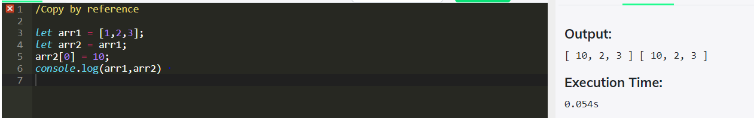

1. How to copy by value a composite data type in JavaScript:

Using **spread operator (…)**

To copy a composite data type by value is to use spread operator that is three dots(…). The spread operator is a new addition to the set of operators in JavaScript ES6. It takes in an iterable (e.g an array) and expands it into individual elements. The spread operator is commonly used to make shallow copies of JS objects.

Using **Object.assign()** method

Object.assign()method which is used to copy the values and properties from one or more source objects to a target object. It returns the target object which has properties and values copied from the source object. On Object.assign() you cannot throw null or undefined source values.

Using **JSON.parse()** and **JSON.stringify()**

The JSON object has two important methods for transforming and storing JSON data: parse () and stringify (). The JSON.parse () method takes a string as input and transforms it into an object. Similarly, JSON.stringify () takes a JSON object and converts it into a string. So use JSON.parse() and JSON.stringify() to copy composite data type by value.